The Innovation Hub
In June 2021, we were delighted to be awarded a grant by the Health Foundation Adopting Innovation programme. Selected as one of four hubs, we will work across NHS organisations in Cambridgeshire and Peterborough to become so good at adapting innovations that we can target new solutions to the most pressing problems we face and improve health outcomes for all.
An innovation is a new idea, practice or object whose application leads to added value, such as better health outcomes or cheaper costs. Spreading these new approaches within the NHS is challenging, but our experience tells us that working alongside citizens and staff really helps.
Co-production is the word we use to describe working together with citizens and staff on the design, delivery, monitoring and evaluation of services. The partners in the Cambridgeshire and Peterborough Innovation Hub are passionate about co-production because we understand innovations need to meet the needs of people who use them.
In accordance with the grant we have been awarded, the programme shall run from Feb 2022 to early 2024.
What will your role be?
The Citizen Participation Group is being established to embed the public voice in the work of the Innovation Hub. As a member of the Citizen Participation Group, you will help to guide the design, delivery, monitoring and evaluation of innovations that are implemented through the Hub. The Citizen Participation Group will bring together a diverse range of citizen views and experiences from across the county to help to ensure that the work of the hub fully represents the views and interests of all.
About you
We are not expecting you to have any prior experience of being a citizen representative. All we ask is that you bring a passion for improving health and care and willingness to draw on your personal experience as a patient, family member or friend. The focus of the hub is to address health inequalities – unfair and avoidable differences in health across the population, and between different groups within society. Health inequalities arise because of conditions in which we are born, grow up, live, work and age. We would therefore love to hear from applicants from a diversity of backgrounds, including age, gender, sexual orientation, disability, ethnicity and income.
What will you get in return?
The role provides a rewarding opportunity to contribute to the transformation of health and care and would be a valuable additional to your C.V. It will mean a commitment of approximately 3 hours a month which you will be paid for at approximately £10 per hour for meetings plus travel, and £20 per hour for additional work. The Citizen Participation Group will appoint two members to join the recruitment panel to appoint the Citizen Chair, who will sit within the hub leadership team.

How to apply: (Closing for applications is 4th April 2022)
Please provide a brief introduction to yourself, and tell us the reasons and motivations for your application in the box below:

Name: Contact Tel No:
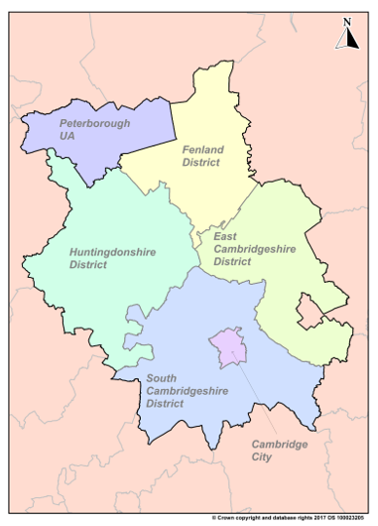
E-mail address:
Why would you like to be a part of the Innovation Hub’s Citizen Participation Group?

Please tell us which district you are from:

☐ Cambridge City ☐ South Cambridgeshire
☐ East Cambridgeshire ☐ Huntingdonshire
☐ Fenland/Isle of Ely ☐ Peterborough
Please return completed forms to:
Helen Oliver/Patrick Williamson
Eastern Academic Health Science Network C
Magog Court
Shelford Bottom
Great Shelford
Cambridge
CB22 3AD
Or e-mail completed form to: InnovationHub@cpft.nhs.uk
*By providing us with your details you are consenting to the collection, use, disclosure, and retention of that information in accordance with our Privacy notice: https://www.cpft.nhs.uk/download.cfm?doc=docm93jijm4n4567.pdf&ver=6186

